**Attack Surface and Attack Vector**

* <https://www.techtarget.com/whatis/definition/attack-surface>
* Attack surfaces are where unauthorized entry can be done. The attack surfaces to be protected are
  + Operating Systems
  + Ports
  + Code
  + Servers
* An attack vector is a path or means by which an attacker or hacker can gain access…

**AWS Cloud Security**

* The tools available in Aws are  
  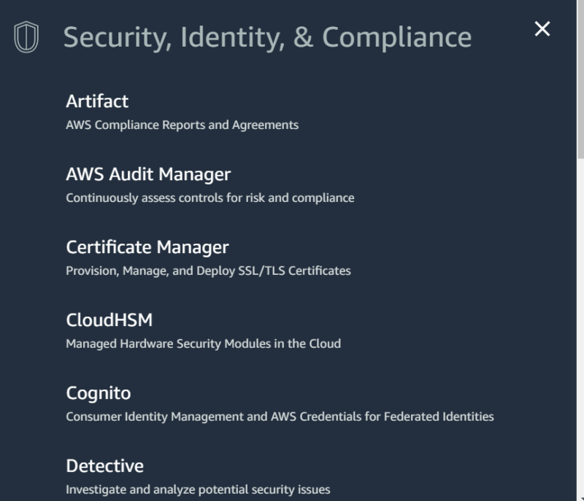  
  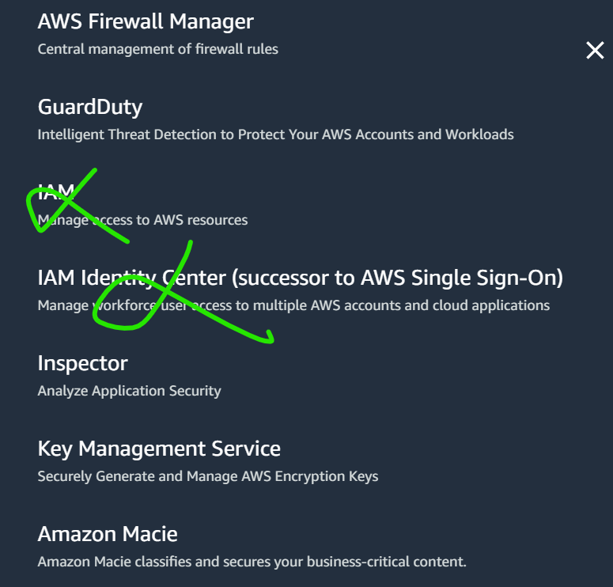  
  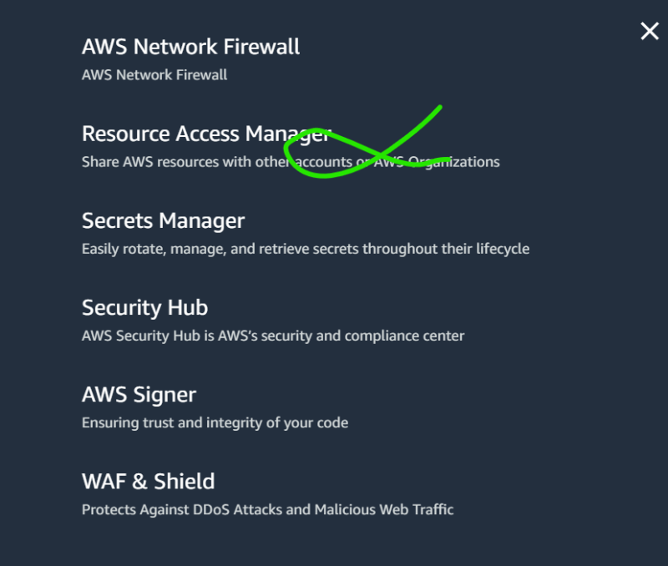
* Gaurd Duty: We can enable security scanning for some services in AWS
* Inspector: Vulnerability Management
* AWS WAF: Provides firewall for your APIs
* AWS Security Hub
* AWS Sheild: Protects for DDOS

**Azure Cloud Security**

* Microsoft Defenders  
  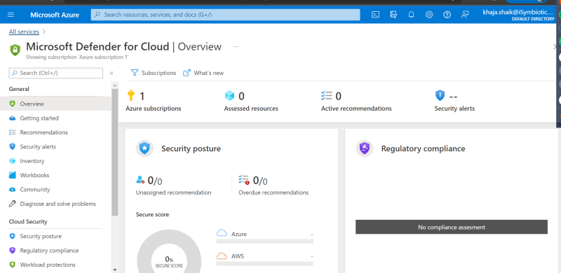
* The tool used is Microsoft Defender for Azure  
  